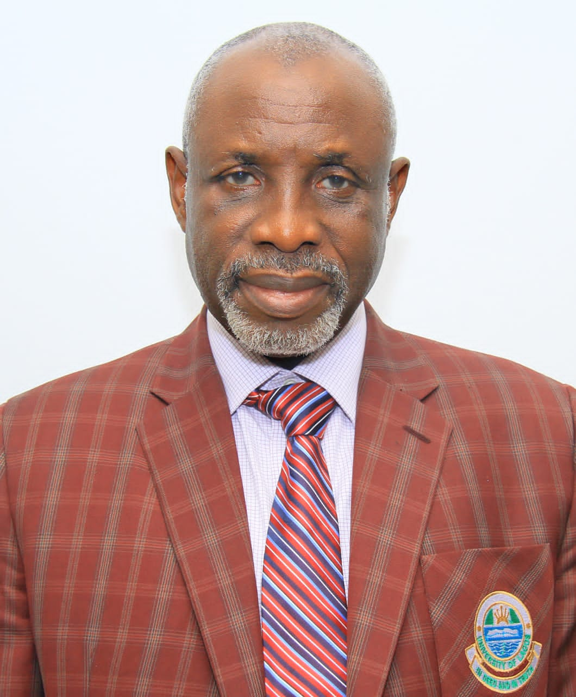

**ENGR. JOHNSON A. AKINWANDE, ELDER-IN-COUNCIL**